|  |
| --- |
| By Cliff Rodriguez |
| Matrix Algebra |
| Date: Due August 13, 2018 |

|  |
| --- |
| Cliff Rodriguez  Date: Due August 13, 2018 |

Contents

**No table of contents entries found.**

**No table of figures entries found.**

# Question 1

Each question will be demonstrated using handwritten math as well as MatLab scripts.

$A=\begin{matrix}6 & 7 & 9 \\ 1 & 2 & 3 \\ 8 & 4 & 6\end{matrix}$ $B=\begin{matrix}10 & 9 & 8 \\ 7 & 5 & 4 \\ 1 & 7 & 6\end{matrix}$ $C=\begin{matrix}1 & 0 & 2 \\ 0 & 1 & 0 \\ 4 & 0 & 2\end{matrix}$

## Handmath

${3B}^{t}+A$

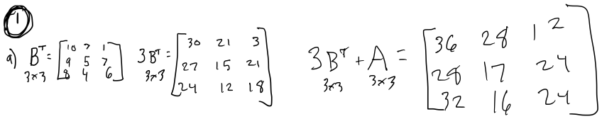

$C^{T}-4A$

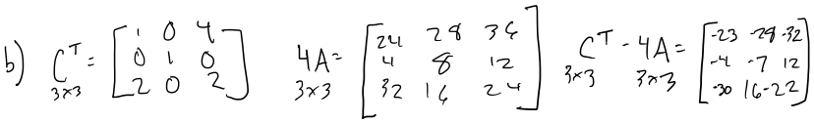

${\left(CA\right)}^{T}$

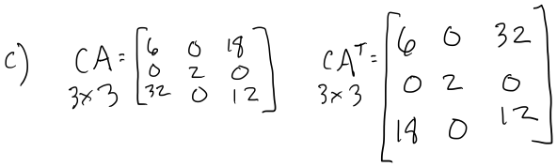

## MatLab

% Problem 1

clear;

A = [6 7 9;

1 2 3;

8 4 6];

B = [10 9 8;

7 5 4;

1 7 6];

C = [1 0 2;

0 1 0;

4 0 2;];

Bt = transpose(B);

Ct = transpose(C);

diary on;

diary('');

%Print Problem 1 Solutions

disp('Problem 1');

% questions a

asolution = [3*Bt + A];

disp('Question a');

display(asolution);

% question b

bsolution = Ct - 4*A;

disp('Question b');

display(bsolution);

% question c

csolution = transpose(C*A);

disp('Question c');

display(csolution);

diary off;

## Console Output

Problem 1

Question a

asolution =

36 28 12

28 17 24

32 16 24

Question b

bsolution =

-23 -28 -32

-4 -7 -12

-30 -16 -22

Question c

csolution =

22 1 40

15 2 36

21 3 48

# Question 2

**Show the rank of each matrix.**



$A=\begin{matrix}6 & 7 & 9 \\ 1 & 2 & 3 \\ 8 & 4 & 6\end{matrix}$

$D=\begin{matrix}10 & 9 & 8 \\ 7 & 5 & 4 \\ 1 & 7 & 6\end{matrix}$

$E=\begin{matrix}1 & 0 & 2 \\ 0 & 1 & 0 \\ 4 & 0 & 2\end{matrix}$

## Handmath

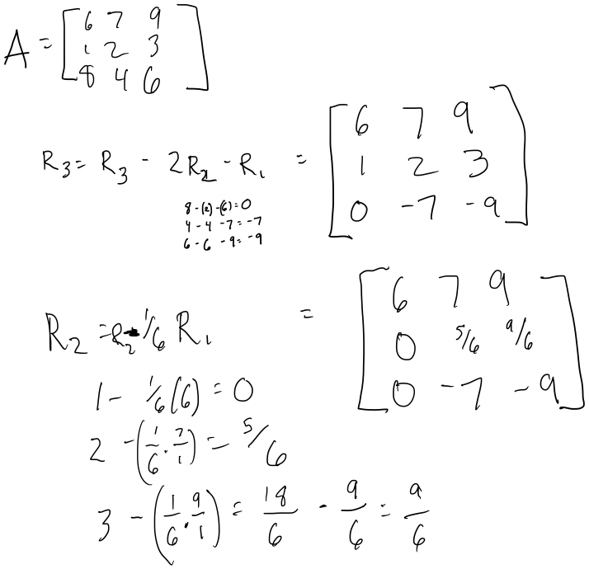



b.

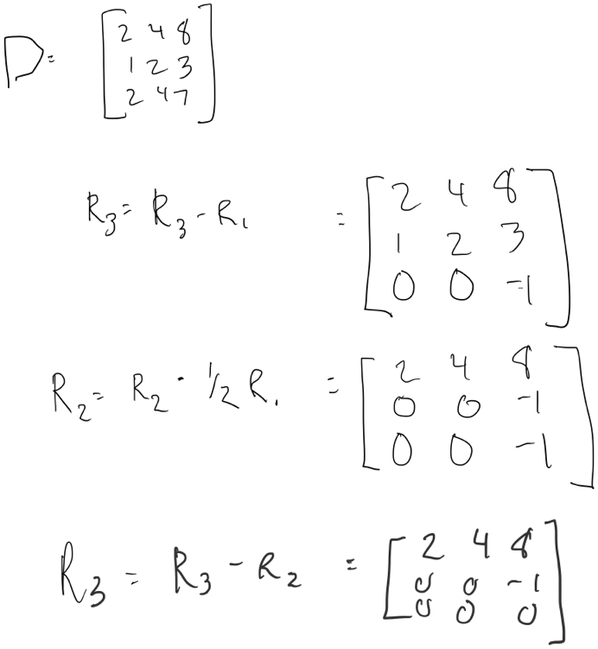

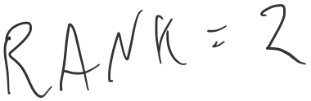

c.

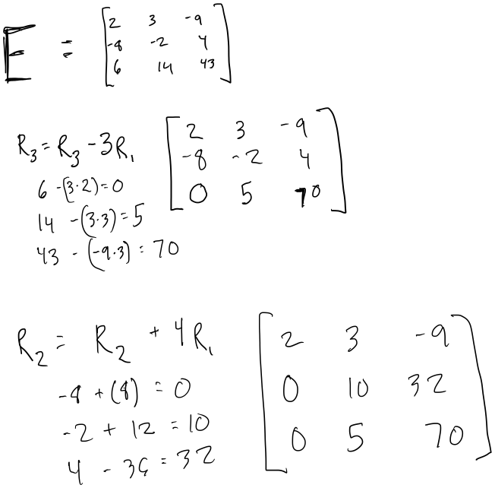

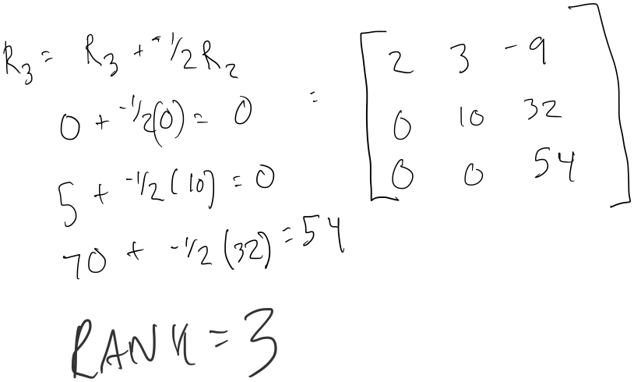

## MatLab

## 

% Problem 2

% question a

disp('Matrix A');

disp(A);

disp('Rank Matrix A = ');

display(rank(A));

% question b

D = [2 4 8;

1 2 3;

2 4 7];

disp('Matrix D =');

disp(D);

disp('Rank Matrix D = ');

display(rank(D));

% question c

E = [2 3 -9;

-8 -2 4;

6 14 43];

disp('Matrix E =');

disp(E);

disp('Rank Matrix E =');

display(rank(E));

diary off;

## Console Output

Matrix A

6 7 9

1 2 3

8 4 6

Rank Matrix A =

3

Matrix D =

2 4 8

1 2 3

2 4 7

Rank Matrix D =

2

Matrix E =

2 3 -9

-8 -2 4

6 14 43

Rank Matrix E =

3

# Question 3

A is not invertable.

B inverse is a.

Inverse of C is b.

# Question 4

$$1_{x_{1}}+ 6_{x_{2}}+ = 4$$

$3_{x_{1}}- 2_{x_{2}}=$ 2

## Handmath

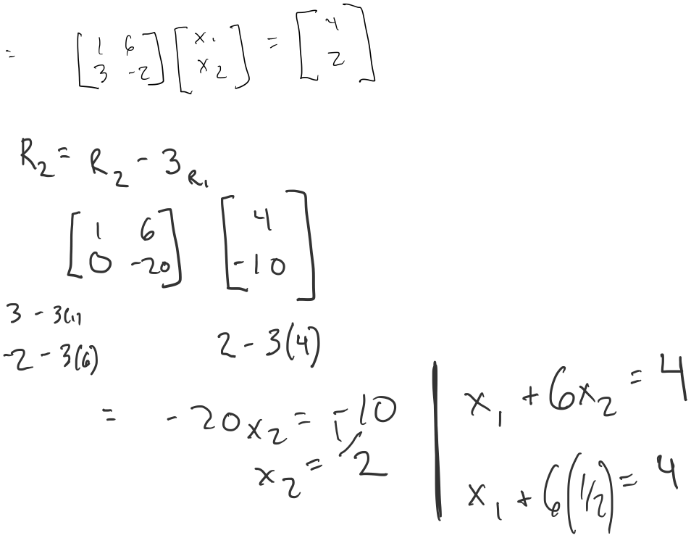

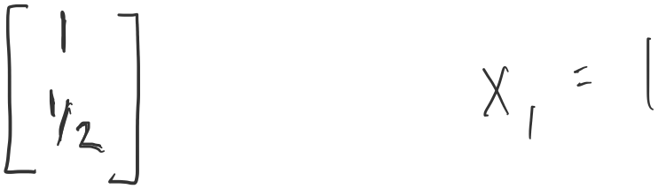

## MatLab

% Author: Cliff Rodriguez

% Linear Algebra Problem 4a

% Demonstrates ToMatrix

% Problem 4

% question a

clear All;

syms x y

eqn1 = 2*x+6*y == 4;

eqn2 = 3*x - 2*y == 2;

[A,B] = equationsToMatrix([eqn1, eqn2], [x, y]);

X = linsolve(A,B);

disp('coefficient matrix');

disp(A);

disp('equals matrix');

disp(B);

disp('solutions:')

disp(X);

## Console Output

>> HW2_Problem4a

coefficient matrix

[ 1, 6]

[ 3, -2]

equals matrix

4

2

solutions:

1

1/2

$$1_{x_{1}}+ 1_{x_{2}}+ 1_{x_{3}}= 6$$

$$3_{x_{1}}- 2_{x_{2}}+ 1_{x_{3}}=2$$

$$4_{x_{1}}+ 2_{x_{2}}- 2_{x_{3}}=2$$

## Handmath

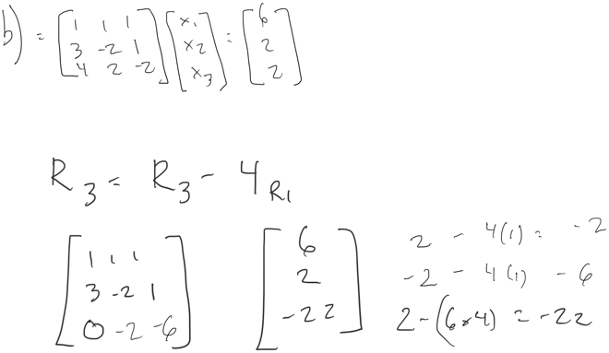

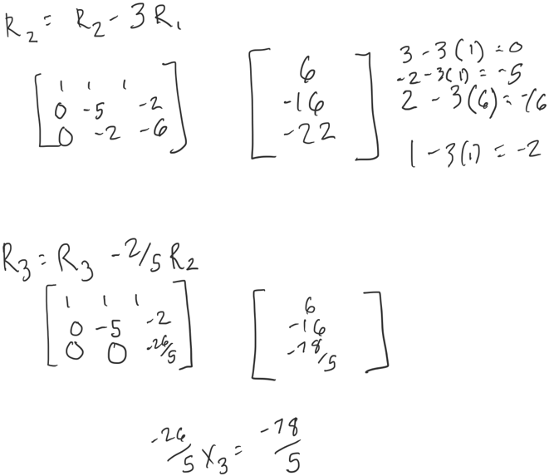

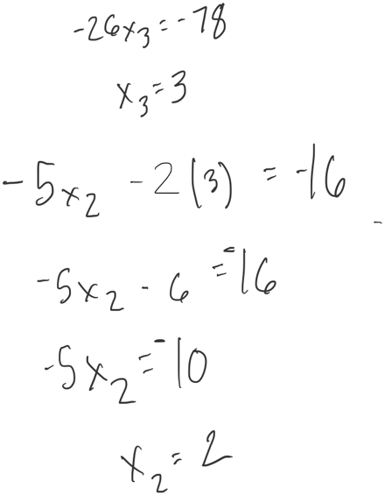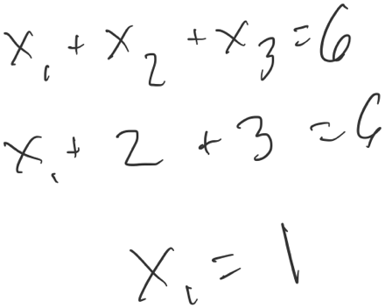

## MatLab

% Author: Cliff Rodriguez

% Linear Algebra Problem 4b

% Demonstrates Solving a set of equations using solve

% Problem 4

% question b

clear All;

syms x y z

eqn1 = 1*x + 1*y + 1*z == 6;

eqn2 = 3*x - 2*y + 3*z == 2;

eqn3 = 4*x + 2*y - 2*z== 2;

sol = solve([eqn1, eqn2 eqn3], [x, y, z]);

xSol = sol.x;

ySol = sol.y;

zSol = sol.z;

disp('x =');

disp(xSol);

disp('y =');

disp(ySol);

disp('z =');

disp(zSol);

## Console Output

>> HW2_Problem4b

>> HW2_Problem4b

x =

1

y =

2

z =

3